PM511B Project

**Date Assigned: Oct 26 2021**

**Date Due: Nov 23 2021**

The STATA dataset project_fall2021 provides data on persons who experienced a traumatic injury and were seen initially in the hospital emergency room, then admitted to the hospital. The dataset contains the following variables:

|  |  |  |
| --- | --- | --- |
| Variable | Description | Codes |
| sid | Patient ID |  |
| died | In-hospital mortality | 0 = survived  1 = died |
| **Use these variables (age through gcs) to develop your prediction model** | | |
| age | Patient age (years) |  |
| male | Gender | 0 = female  1 = male |
| race | Race/ethnicity | 1 = Asian  2 = African-American  3 = Non-Hispanic white  4 = Hispanic white |
| **All variables below are initial measures obtained in the emergency room** | | |
| sbp | Systolic blood pressure (mm Hg)  Healthy resting systolic BP is about 120 |  |
| rr | Respiratory rate (breaths per minute)  Normal is about 12-20 |  |
| gcs | Glasgow Coma Scale: a neurologic measure of level of consciousness. Lower scores indicate lower level of consciousness. Sometimes used to estimate extent of brain injury. Severe injury: GCS<9  Moderate injury: GCS 9-12  Minor or no injury: GCS>12 | Range 1-15 |
| **Use variable below to determine whether subject data is used in estimation (training) vs. validation** | | |
| val | Use in estimation vs. validation sample | 0 = estimation sample  1 = validation sample |
| **Use the measure below ONLY for Part 10** | | |
| asaps | A measure of physical fitness for surgery:  1: Healthy  2: Mild systemic disease  3: Severe systemic disease  4: Severe systemic disease that is a constant threat to life  5: Not expected to survive without operation | Range 1-5 |

General instructions:

1. This project is to be completed alone. Any evidence of the following will result in an F in the course and will be referred to student judicial affairs:  
   Sharing of programs or text with other students  
   Direct use of text from textbook, lectures, lab materials or other sources
2. The project should be turned in on Blackboard by the due date 11/23.
3. **Turn in two project files**:  
   1. Responses to the questions below, which may include text, tables and figures.  
        
      Title this file **“pm511bproject_text_lastname_firstname”**  
      **This document should be no longer than 15 pages, using Arial Font 11. Any documents longer than 15 pages will not be accepted.**
   2. Your stata smcl file(s), organized by the question (e.g. 1a, 1b, etc.)  
        
      Title this file **“pm511bproject_smcl_lastname_firstname**”  
      Suggestion: When you have completed your responses and have an error-free working program, run the program, saving to the smcl file referenced above.  
        
      **Do NOT wait to the last minute to figure out how to save your program statements and results to this smcl file!**

Assignment: Investigators want to use these data to develop a predictive model for in-hospital mortality among patients with trauma. **Use the subjects with val=0** **(the estimation sample)** in these data to develop a predictive model for in-hospital mortality.

1. Provide a **publication-quality** descriptive table of the sample (with val=0) on the variables above. Report your summary statistics (means, frequencies, etc.) separately by mortality (i.e., your table will have 2 columns – died and survived).   
   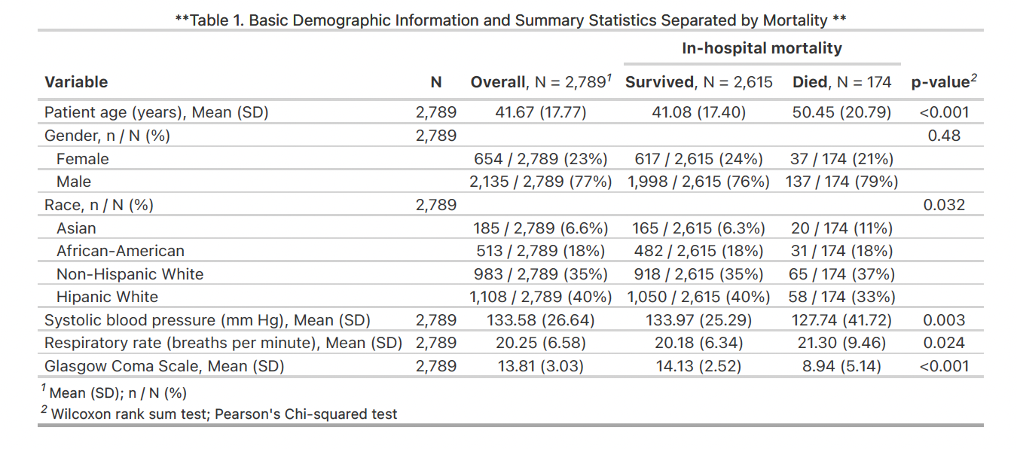
   1. Write a **short** paragraph describing the sample and possible differences by mortality.  
      Patient age seems statistically different (p<.001) in the survived group compared to the died group, with the died group having a higher average age. Gender is not statistically different in the two mortality groups. But there seems to be more males than female patients. Race seems roughly equally distributed between the two mortality groups. SBP is statistically significantly different in the two mortality groups, with the died group having less SBP on average. Respiratory rate is significantly different in the two groups with those who died having higher RR. Glasgow Coma Scale was highly significantly different between the two groups (<.001) with those who died having a lower average score.
2. Using the listed variables above (age through gcs), develop a predictive model (among subjects with val=0), considering main effects and 2-way interactions as possible model terms. Pay attention to how you model continuous variables. Show all of your steps in developing your predictive model. At each step, provide a rationale for the modeling choices you have made.  
   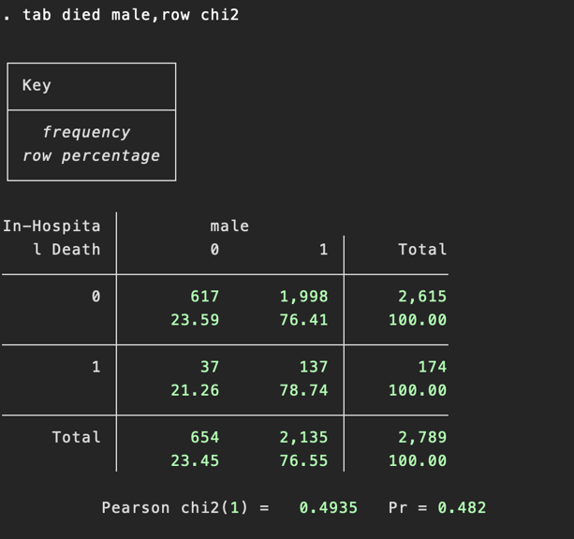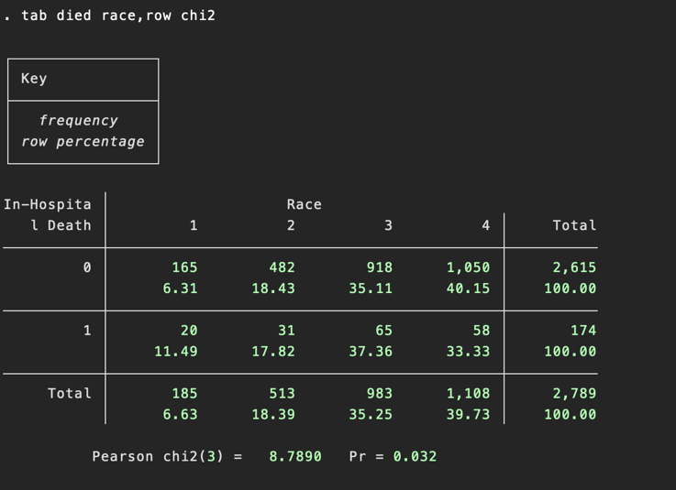







** **

**Logistic regression**

|  |  |  |  |  |  |  |  |  |  |  |  |
| --- | --- | --- | --- | --- | --- | --- | --- | --- | --- | --- | --- |
| died | Coef. | | St.Err. | t-value | | p-value | [95% Conf | | Interval] | | Sig |
| age | .026 | | .004 | 6.58 | | 0 | .018 | | .034 | | *** |
| Constant | -3.911 | | .214 | -18.28 | | 0 | -4.33 | | -3.491 | | *** |
|  | | | | | | | | | | | |
| Mean dependent var | | 0.062 | | | SD dependent var | | | 0.242 | |
| Pseudo r-squared | | 0.032 | | | Number of obs | | | 2789 | |
| Chi-square | | 41.558 | | | Prob > chi2 | | | 0.000 | |
| Akaike crit. (AIC) | | 1264.839 | | | Bayesian crit. (BIC) | | | 1276.706 | |

|  |  |  |  |  |  |  |  |  |  |  |  |
| --- | --- | --- | --- | --- | --- | --- | --- | --- | --- | --- | --- |
| died | Coef. | | St.Err. | t-value | | p-value | [95% Conf | | Interval] | | Sig |
| male | .134 | | .191 | 0.70 | | .483 | -.24 | | .508 | |  |
| Constant | -2.814 | | .169 | -16.63 | | 0 | -3.146 | | -2.482 | | *** |
|  | | | | | | | | | | | |
| Mean dependent var | | 0.062 | | | SD dependent var | | | 0.242 | |
| Pseudo r-squared | | 0.000 | | | Number of obs | | | 2789 | |
| Chi-square | | 0.504 | | | Prob > chi2 | | | 0.478 | |
| Akaike crit. (AIC) | | 1305.893 | | | Bayesian crit. (BIC) | | | 1317.760 | |

|  |  |  |  |  |  |  |  |  |  |  |  |
| --- | --- | --- | --- | --- | --- | --- | --- | --- | --- | --- | --- |
| died | Coef. | | St.Err. | t-value | | p-value | [95% Conf | | Interval] | | Sig |
| Race : base 1 | 0 | | . | . | | . | . | | . | |  |
| 2 | -.634 | | .301 | -2.11 | | .035 | -1.223 | | -.044 | | ** |
| 3 | -.538 | | .269 | -2.00 | | .046 | -1.065 | | -.01 | | ** |
| 4 | -.786 | | .272 | -2.88 | | .004 | -1.32 | | -.252 | | *** |
| Constant | -2.11 | | .237 | -8.91 | | 0 | -2.574 | | -1.646 | | *** |
|  | | | | | | | | | | | |
| Mean dependent var | | 0.062 | | | SD dependent var | | | 0.242 | |
| Pseudo r-squared | | 0.006 | | | Number of obs | | | 2789 | |
| Chi-square | | 7.772 | | | Prob > chi2 | | | 0.051 | |
| Akaike crit. (AIC) | | 1302.625 | | | Bayesian crit. (BIC) | | | 1326.359 | |

|  |  |  |  |  |  |  |  |  |  |  |  |
| --- | --- | --- | --- | --- | --- | --- | --- | --- | --- | --- | --- |
| died | Coef. | | St.Err. | t-value | | p-value | [95% Conf | | Interval] | | Sig |
| sbp | -.009 | | .003 | -2.99 | | .003 | -.014 | | -.003 | | *** |
| Constant | -1.565 | | .383 | -4.09 | | 0 | -2.315 | | -.814 | | *** |
|  | | | | | | | | | | | |
| Mean dependent var | | 0.062 | | | SD dependent var | | | 0.242 | |
| Pseudo r-squared | | 0.007 | | | Number of obs | | | 2789 | |
| Chi-square | | 8.912 | | | Prob > chi2 | | | 0.003 | |
| Akaike crit. (AIC) | | 1297.485 | | | Bayesian crit. (BIC) | | | 1309.352 | |

|  |  |  |  |  |  |  |  |  |  |  |  |
| --- | --- | --- | --- | --- | --- | --- | --- | --- | --- | --- | --- |
| died | Coef. | | St.Err. | t-value | | p-value | [95% Conf | | Interval] | | Sig |
| rr | .02 | | .009 | 2.16 | | .031 | .002 | | .038 | | ** |
| Constant | -3.123 | | .21 | -14.84 | | 0 | -3.535 | | -2.71 | | *** |
|  | | | | | | | | | | | |
| Mean dependent var | | 0.062 | | | SD dependent var | | | 0.242 | |
| Pseudo r-squared | | 0.003 | | | Number of obs | | | 2789 | |
| Chi-square | | 3.978 | | | Prob > chi2 | | | 0.046 | |
| Akaike crit. (AIC) | | 1302.418 | | | Bayesian crit. (BIC) | | | 1314.285 | |

|  |  |  |  |  |  |  |  |  |  |  |  |
| --- | --- | --- | --- | --- | --- | --- | --- | --- | --- | --- | --- |
| died | Coef. | | St.Err. | t-value | | p-value | [95% Conf | | Interval] | | Sig |
| gcs | -.284 | | .017 | -17.02 | | 0 | -.317 | | -.251 | | *** |
| Constant | .745 | | .193 | 3.86 | | 0 | .367 | | 1.124 | | *** |
|  | | | | | | | | | | | |
| Mean dependent var | | 0.062 | | | SD dependent var | | | 0.242 | |
| Pseudo r-squared | | 0.209 | | | Number of obs | | | 2789 | |
| Chi-square | | 272.532 | | | Prob > chi2 | | | 0.000 | |
| Akaike crit. (AIC) | | 1033.865 | | | Bayesian crit. (BIC) | | | 1045.732 | |
| *\*\*\* p<.01, ** p<.05, * p<.1* | | | | | | | | | | | |
|  | | | | | | | | | | | |

Preliminary model selected from univariate regressions where p<0.25

**Logistic regression**

|  |  |  |  |  |  |  |  |  |  |  |  |
| --- | --- | --- | --- | --- | --- | --- | --- | --- | --- | --- | --- |
| died | Coef. | | St.Err. | t-value | | p-value | [95% Conf | | Interval] | | Sig |
| age | .037 | | .005 | 7.59 | | 0 | .027 | | .046 | | *** |
| Race : base 1 | 0 | | . | . | | . | . | | . | |  |
| 2 | .197 | | .361 | 0.55 | | .586 | -.511 | | .905 | |  |
| 3 | -.107 | | .32 | -0.33 | | .738 | -.735 | | .521 | |  |
| 4 | -.234 | | .325 | -0.72 | | .471 | -.87 | | .403 | |  |
| sbp | -.009 | | .003 | -3.10 | | .002 | -.014 | | -.003 | | *** |
| rr | .035 | | .009 | 3.68 | | 0 | .016 | | .054 | | *** |
| gcs | -.305 | | .018 | -16.59 | | 0 | -.341 | | -.269 | | *** |
| Constant | -.222 | | .549 | -0.40 | | .686 | -1.299 | | .855 | |  |
|  | | | | | | | | | | | |
| Mean dependent var | | 0.062 | | | SD dependent var | | | 0.242 | |
| Pseudo r-squared | | 0.266 | | | Number of obs | | | 2789 | |
| Chi-square | | 345.829 | | | Prob > chi2 | | | 0.000 | |
| Akaike crit. (AIC) | | 972.568 | | | Bayesian crit. (BIC) | | | 1020.036 | |
| *\*\*\* p<.01, ** p<.05, * p<.1* | | | | | | | | | | | |

Removed Race due to race being non-significant in improving model fit using LR test compared to model without race (p=.42)

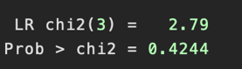

**Logistic regression**

|  |  |  |  |  |  |  |  |  |  |  |  |
| --- | --- | --- | --- | --- | --- | --- | --- | --- | --- | --- | --- |
| died | Coef. | | St.Err. | t-value | | p-value | [95% Conf | | Interval] | | Sig |
| age | .036 | | .005 | 7.70 | | 0 | .027 | | .046 | | *** |
| sbp | -.009 | | .003 | -3.14 | | .002 | -.014 | | -.003 | | *** |
| rr | .034 | | .01 | 3.61 | | 0 | .016 | | .053 | | *** |
| gcs | -.303 | | .018 | -16.72 | | 0 | -.339 | | -.268 | | *** |
| Constant | -.284 | | .464 | -0.61 | | .54 | -1.192 | | .624 | |  |
|  | | | | | | | | | | | |
| Mean dependent var | | 0.062 | | | SD dependent var | | | 0.242 | |
| Pseudo r-squared | | 0.263 | | | Number of obs | | | 2789 | |
| Chi-square | | 343.034 | | | Prob > chi2 | | | 0.000 | |
| Akaike crit. (AIC) | | 969.363 | | | Bayesian crit. (BIC) | | | 999.030 | |
| *\*\*\* p<.01, ** p<.05, * p<.1* | | | | | | | | | | | |

Now add back male which was not included due to non-sig univariate regression. It’s now significant (p=.027). So, keep in preliminary model

**Logistic regression**

|  |  |  |  |  |  |  |  |  |  |  |  |
| --- | --- | --- | --- | --- | --- | --- | --- | --- | --- | --- | --- |
| died | Coef. | | St.Err. | t-value | | p-value | [95% Conf | | Interval] | | Sig |
| age | .039 | | .005 | 7.93 | | 0 | .029 | | .048 | | *** |
| male | .492 | | .222 | 2.22 | | .027 | .057 | | .926 | | ** |
| sbp | -.009 | | .003 | -3.24 | | .001 | -.014 | | -.004 | | *** |
| rr | .035 | | .01 | 3.63 | | 0 | .016 | | .053 | | *** |
| gcs | -.304 | | .018 | -16.70 | | 0 | -.34 | | -.268 | | *** |
| Constant | -.733 | | .507 | -1.44 | | .149 | -1.727 | | .261 | |  |
|  | | | | | | | | | | | |
| Mean dependent var | | 0.062 | | | SD dependent var | | | 0.242 | |
| Pseudo r-squared | | 0.267 | | | Number of obs | | | 2789 | |
| Chi-square | | 348.241 | | | Prob > chi2 | | | 0.000 | |
| Akaike crit. (AIC) | | 966.156 | | | Bayesian crit. (BIC) | | | 1001.756 | |
| *\*\*\* p<.01, ** p<.05, * p<.1* | | | | | | | | | | | |

Now fractional polynomial test to test linearity of individual continuous variables to determine possible transformations

First test for age

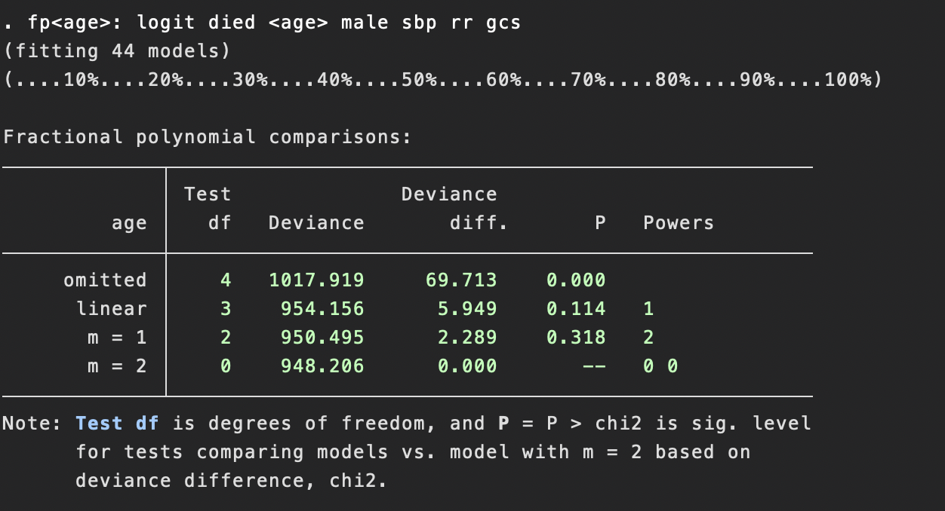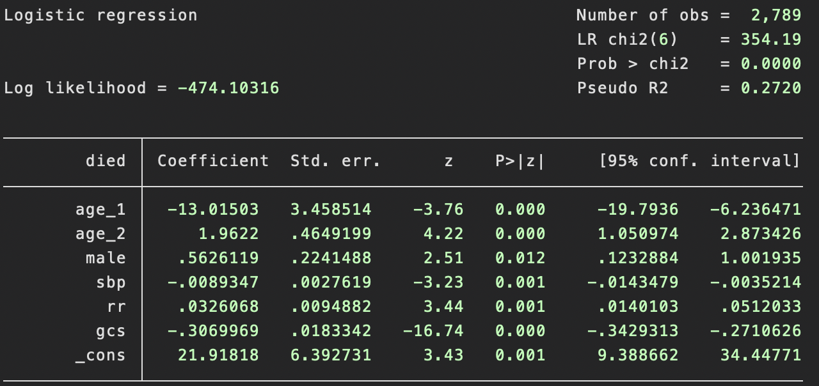

The best 1 term model is not significantly different from the best two term model (p=0.318).

The linear model is not significantly different from the best two term model (p=0.114).

The linear model is not significantly different from the best 1 term model:

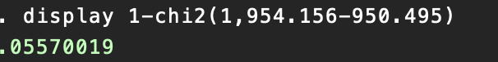

The linear model is significantly different from model without age:

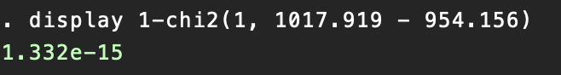

So keep age as linear. Next we check SBP

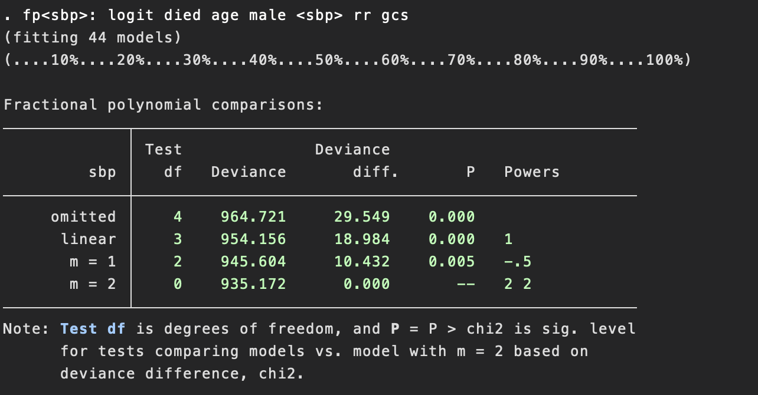

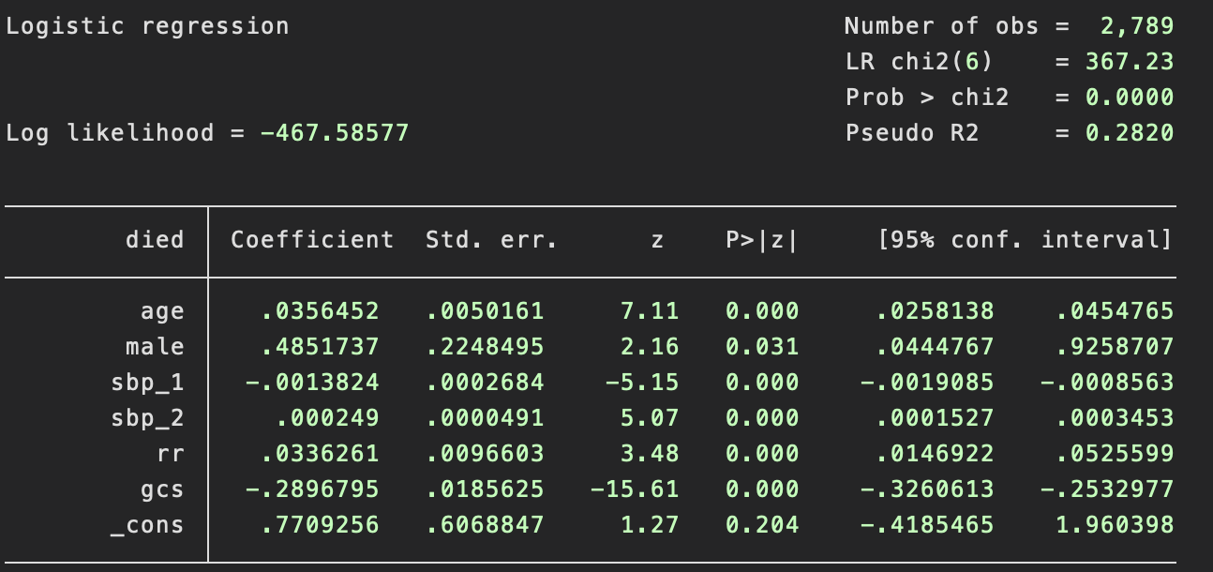

So the best two term model is significantly different from the best 1-term model (p=0.005).

The best two term model is significantly different from the linear model (p<0.001).

The 1 term model is significantly different from the linear model:

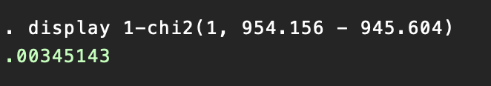

We choose the 2-term model, where sbp_1 = (sbp)^2, and sbp_2 = ((sbp)^2)*ln(sbp)

Next we check the variable “rr”

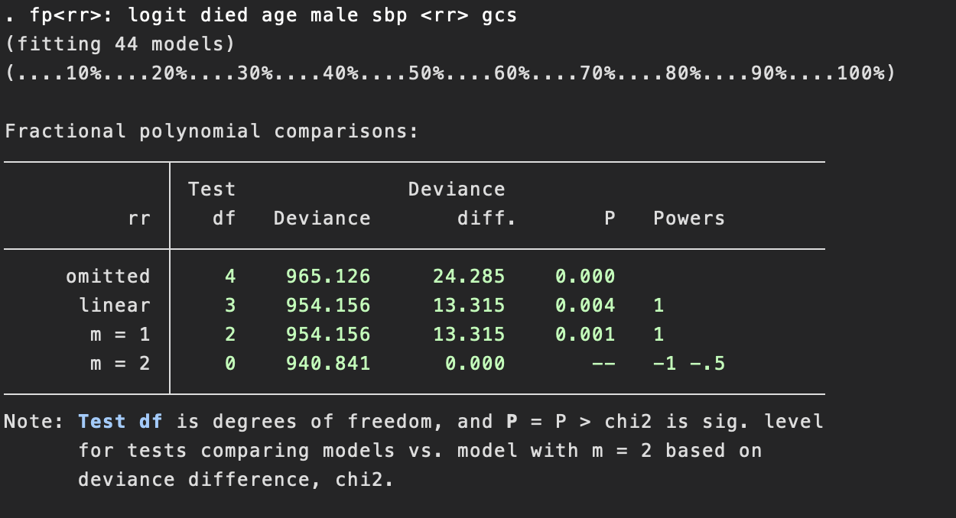

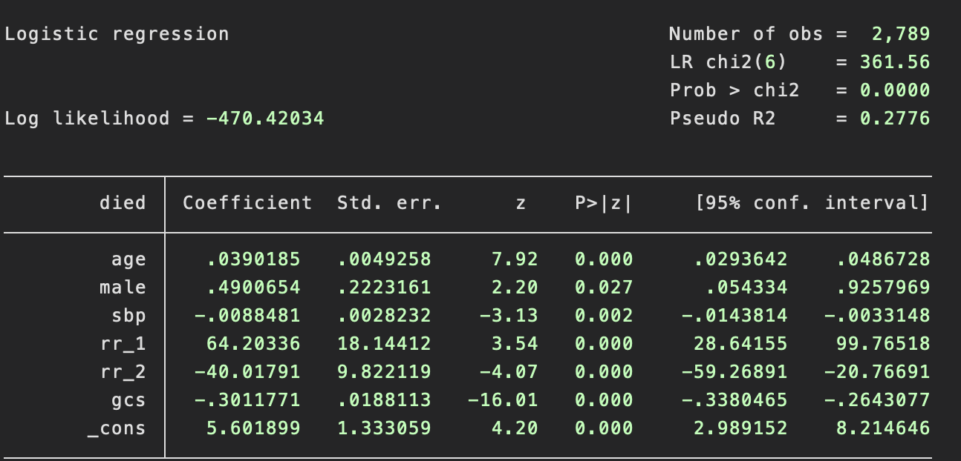

The best two term model is significantly different from the best 1-term model (p=0.001).

The best two-term model is significantly different from the linear model (p=0.004).

So we use two term model where rr_1 = 1/(rr) and rr_2 = (1/sqrt(rr))

Next we check gcs.

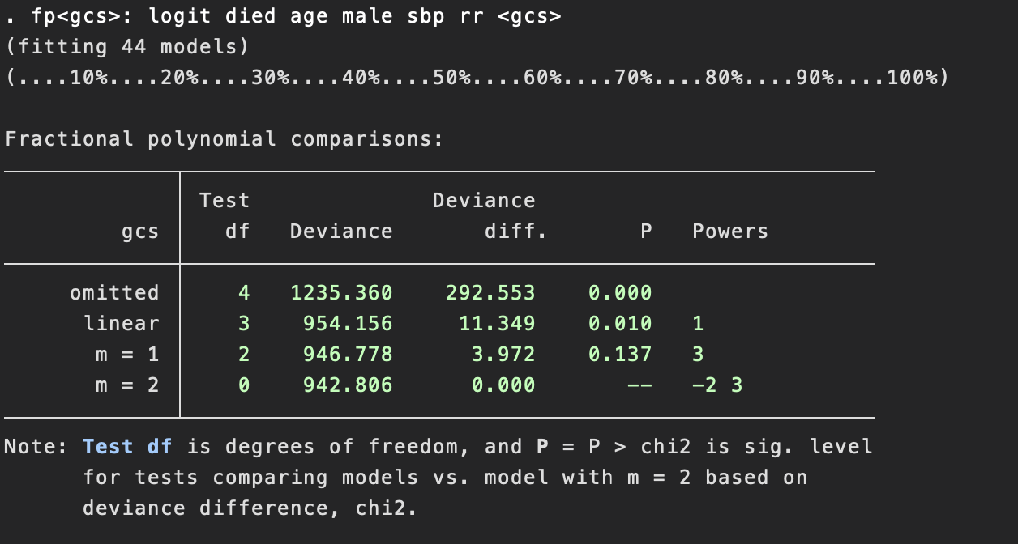

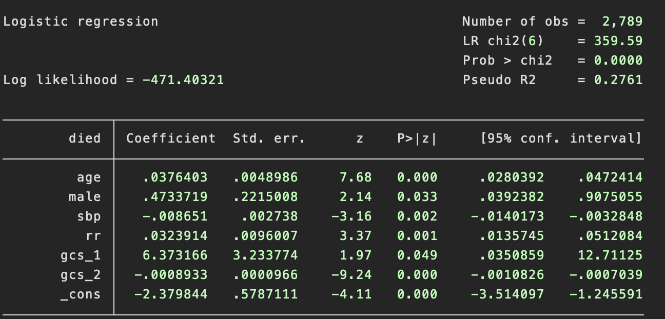

The best two term model is not significantly different from the best 1-term model (p=0.137).

The best 1-term model is significantly different form the linear model (p<.01)

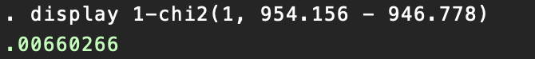

The linear model is significantly different from the model without gcs (p<.001)



So we select the 1-term model where gcs_1 = gcs^3

So we restrict the dimension and use gcs_1 in future modeling.

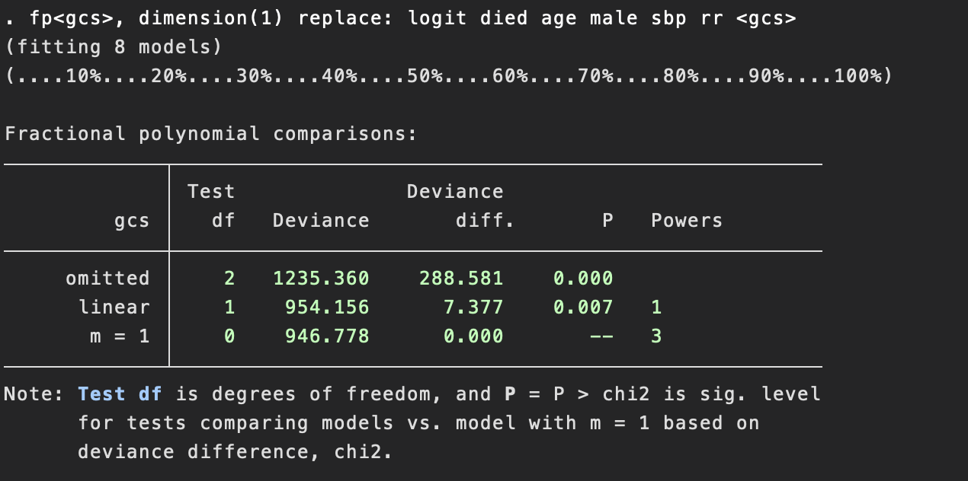

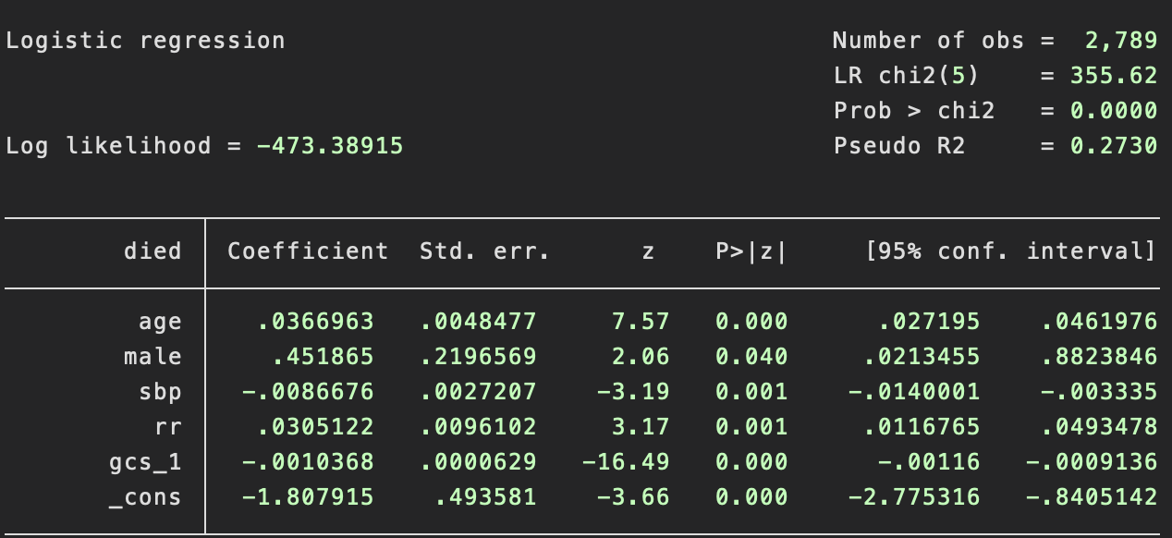

Now we have the base model as

logistic died age male sbp_1 sbp_2 rr_1 rr_2 gcs_1

Testing for all possible two-way interactions between base terms using lrtest.

Significant interactions are shown below.

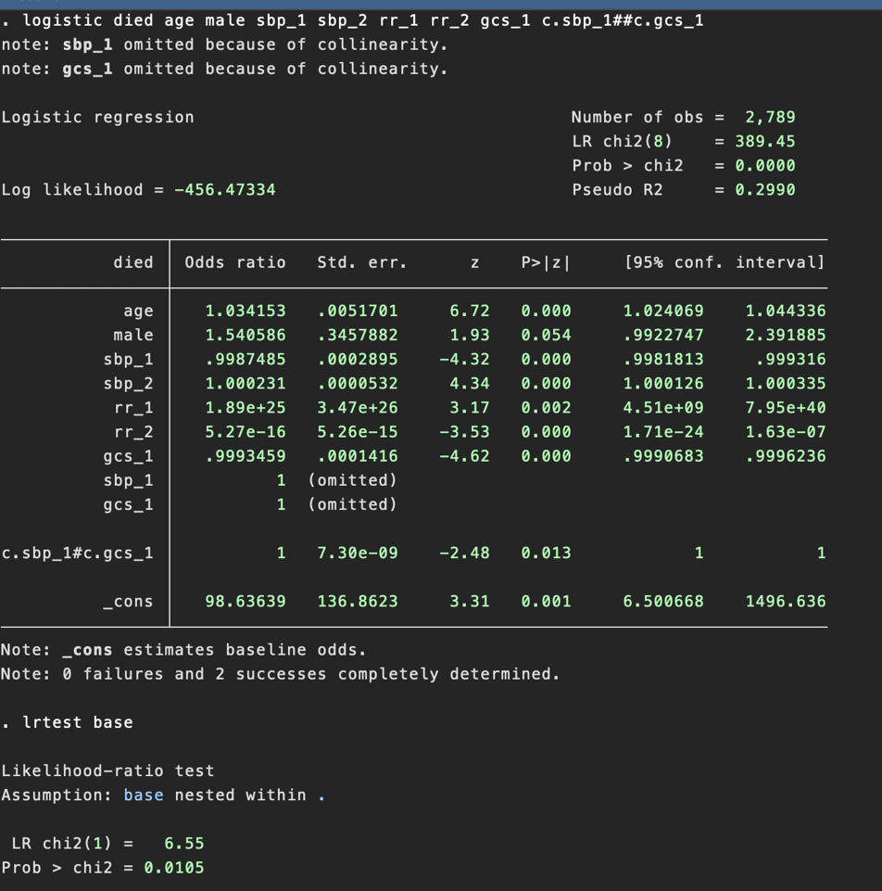

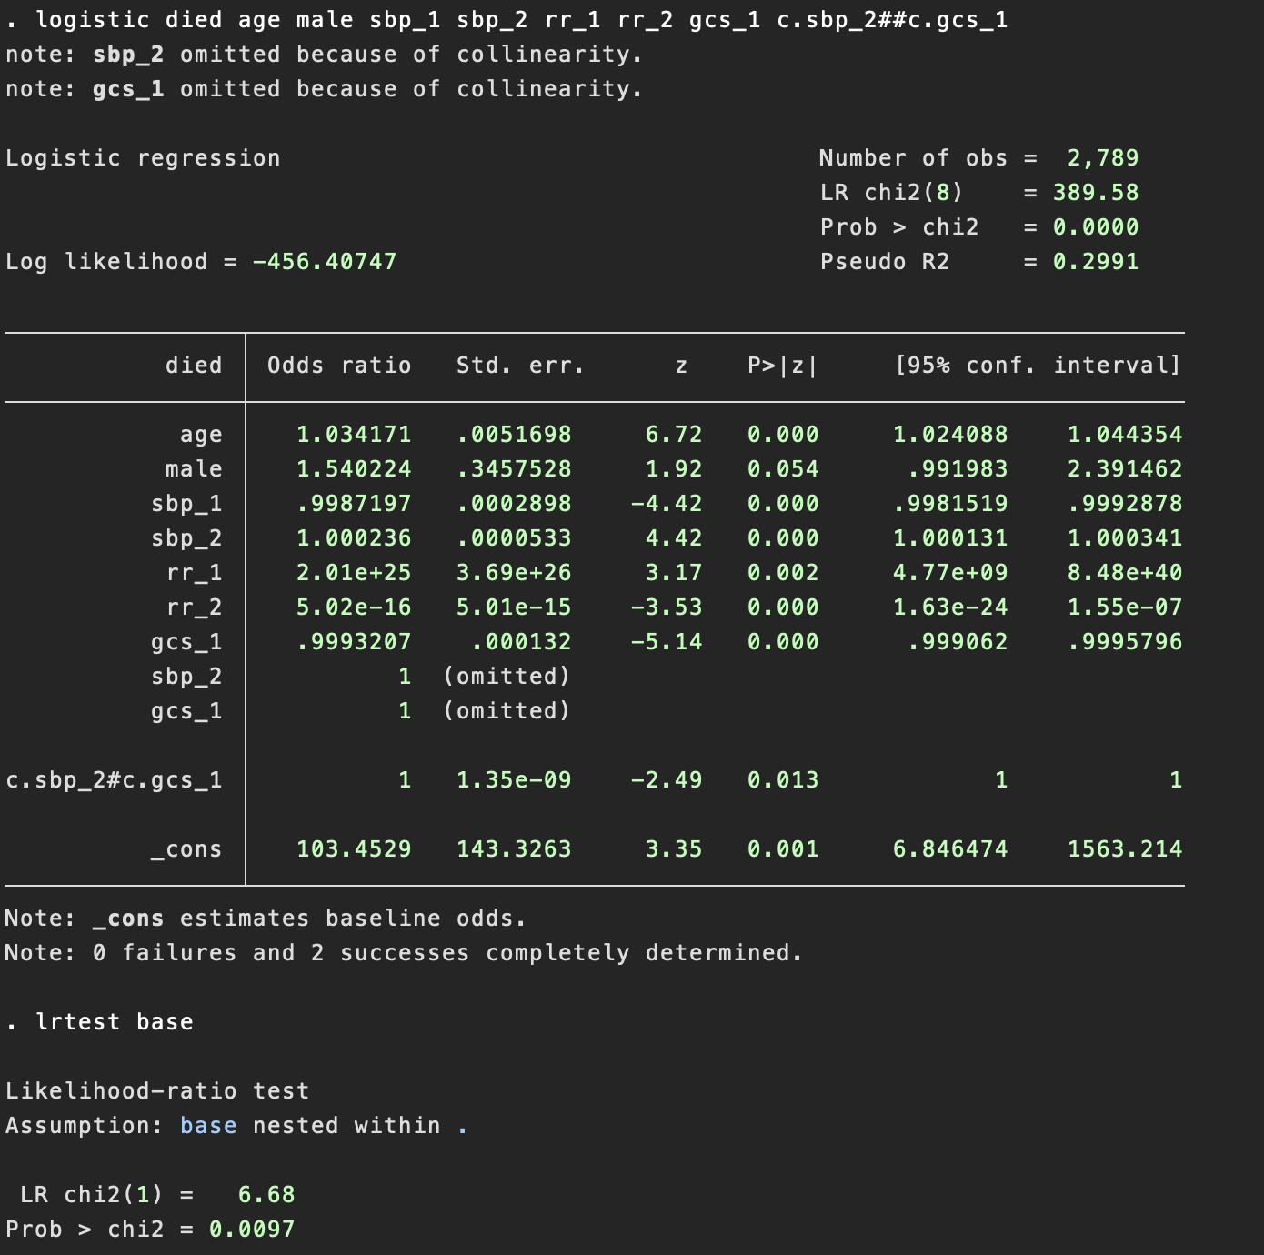

There are two significant interactions, namely sbp_1##gcs_1 (LR test p=.01) and sbp_2##gcs_1 (LR test p=.0097).

Including those interactions in the model, the model then becomes

logistic died age male sbp_1 sbp_2 rr_1 rr_2 gcs_1 c.sbp_1##c.gcs_1 c.sbp_2##c.gcs_1

Likelihood ratio test shows that this model is significantly different (p=0.0267) from the base model without interaction terms.

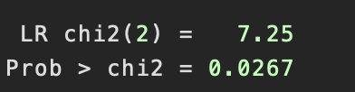

So, the preliminary final model is as defined above.

1. Provide an appropriate test of goodness of fit. Interpret the result.  
   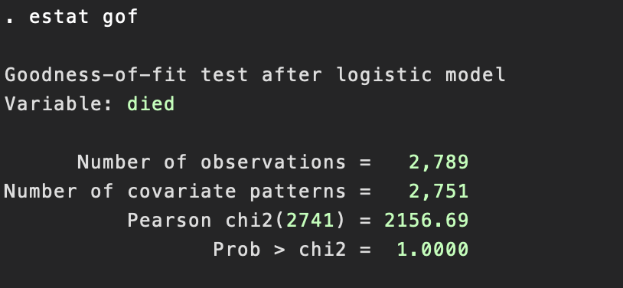

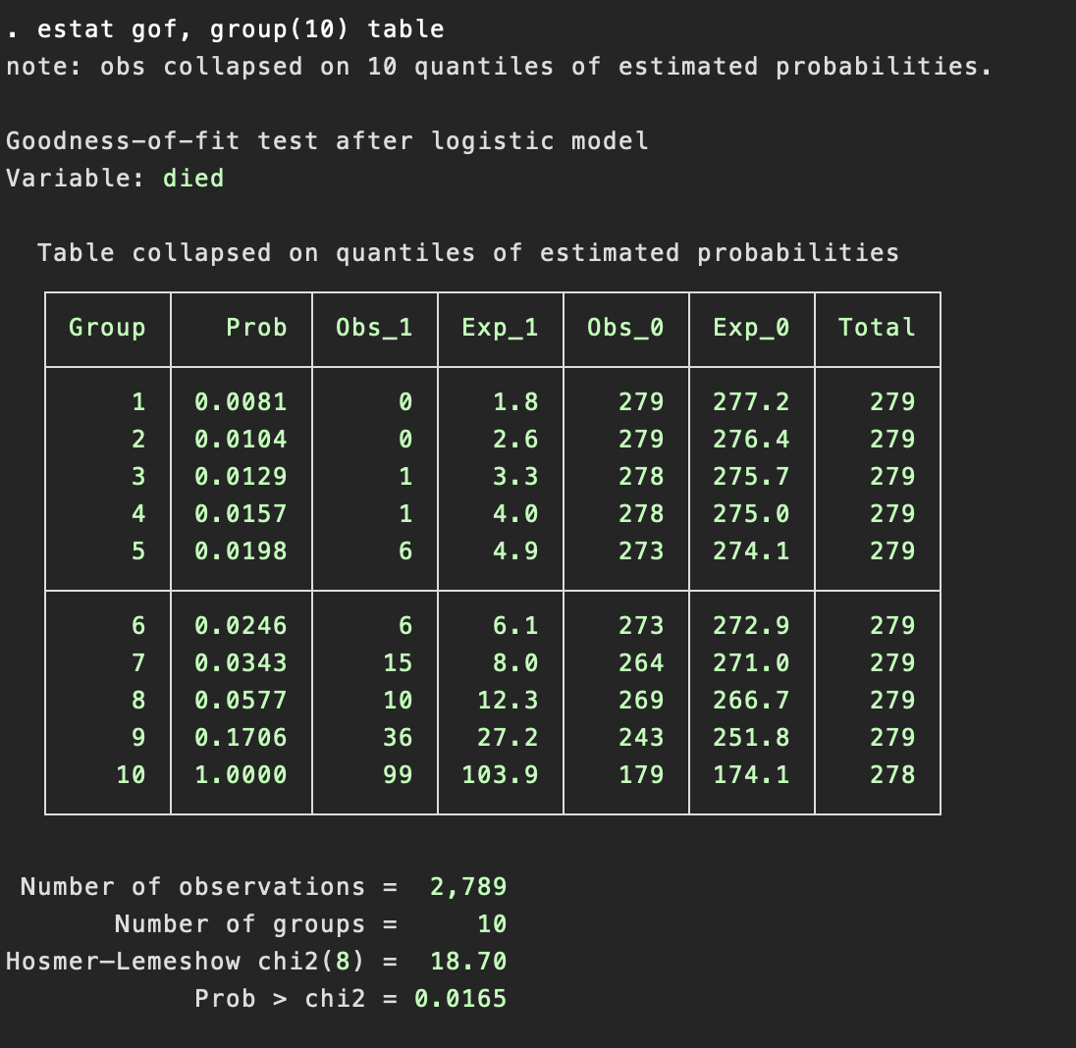

Both Pearson GOF test and Hosmer–Lemeshow GOF test are performed. However, Hosmer–Lemeshow is preferred because number of covariate patterns (2751) is approaching number of observations (2789). The by Hosmer–Lemeshow, our model has poor fit (p=0.0165).

1. Complete model diagnostics and re-fit your model if needed. Explain any issues you might find in this process and how you will deal with it in your model.

First compute predicted probabilities and diagnostic statistics (delta chi-sqaure, delta-deviance, delta beta)

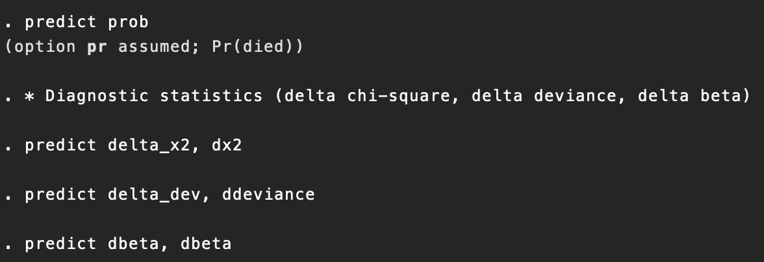

Now plot delta chi-square vs. predicted probabilities (left) and delta deviance vs. predicted probabilities (right)  


Next, plot delta beta vs predicted probabilities (left) and plot with symbol size proportional to delta beta (right)

 

Now we identify covariate patterns with higher values of delta chi- square, delta beta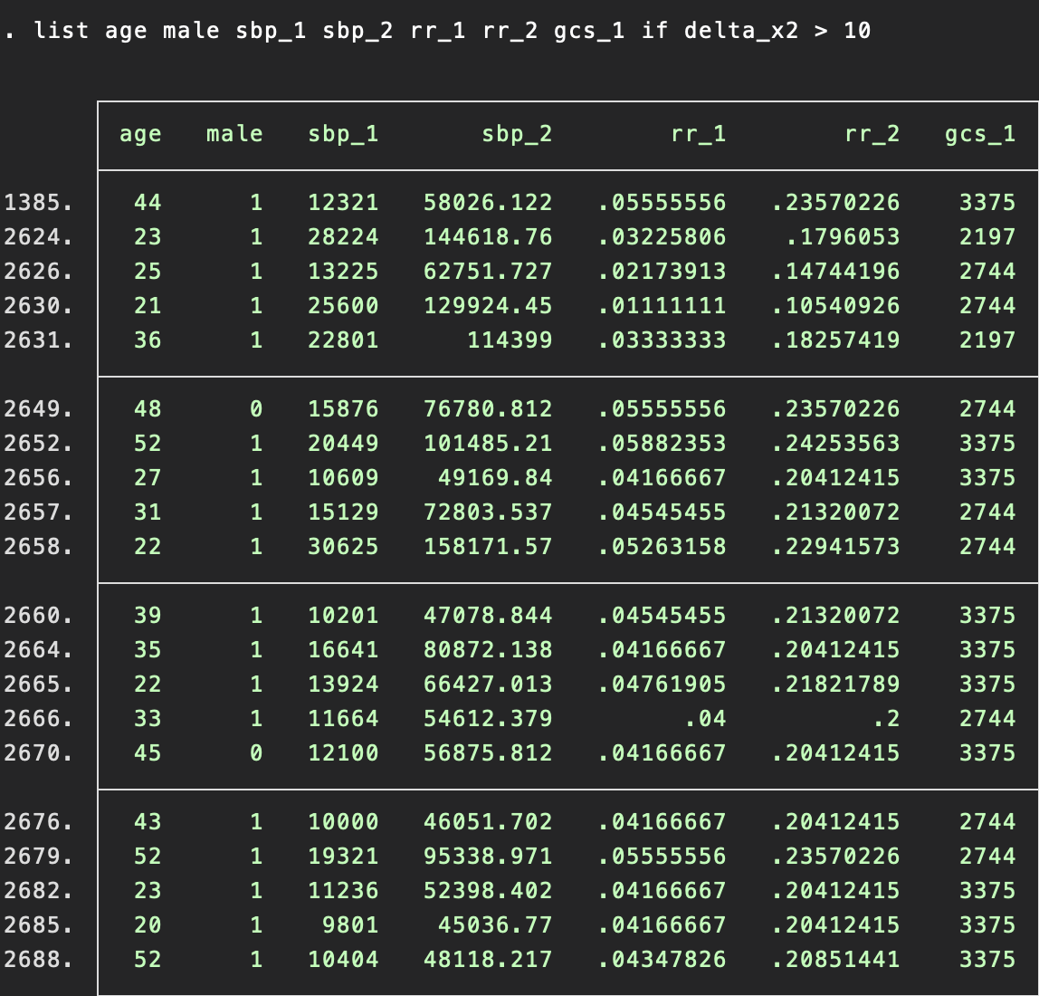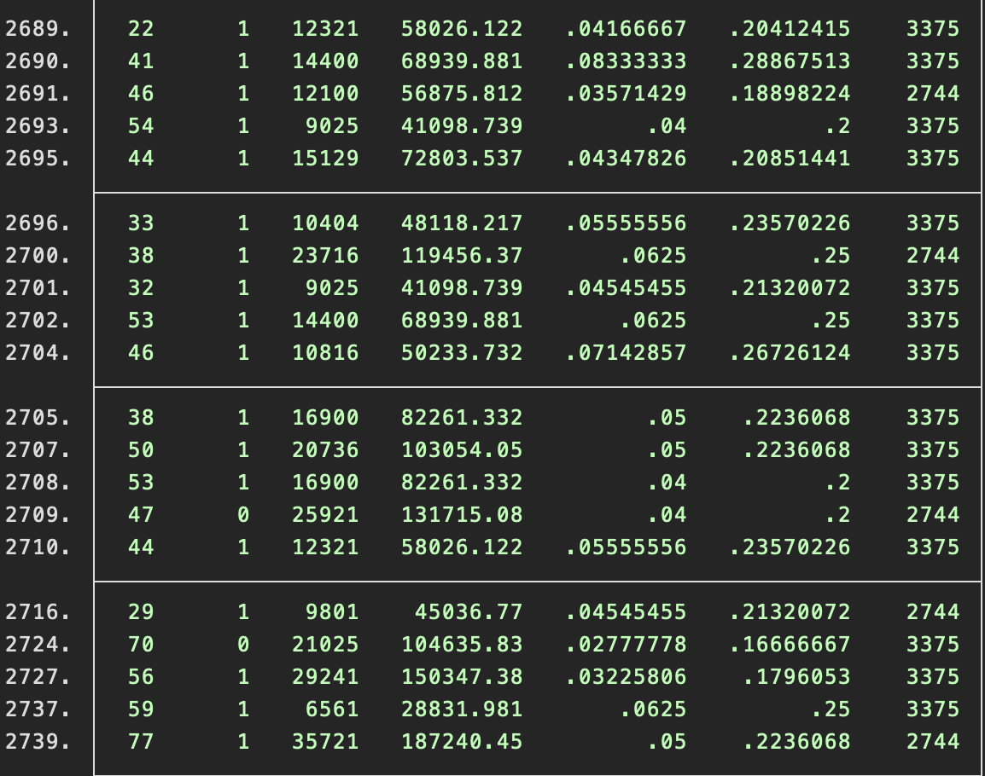

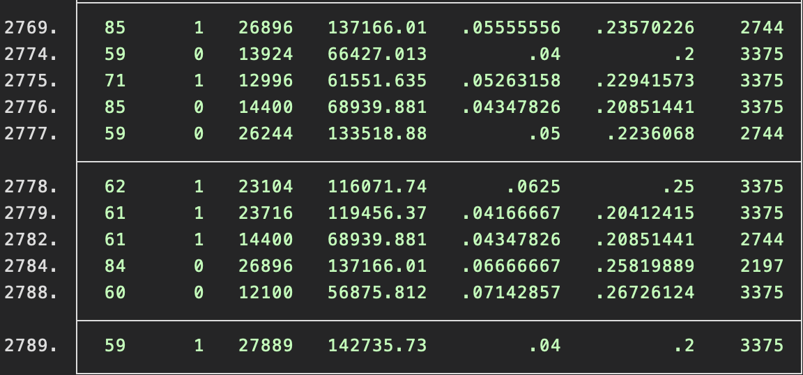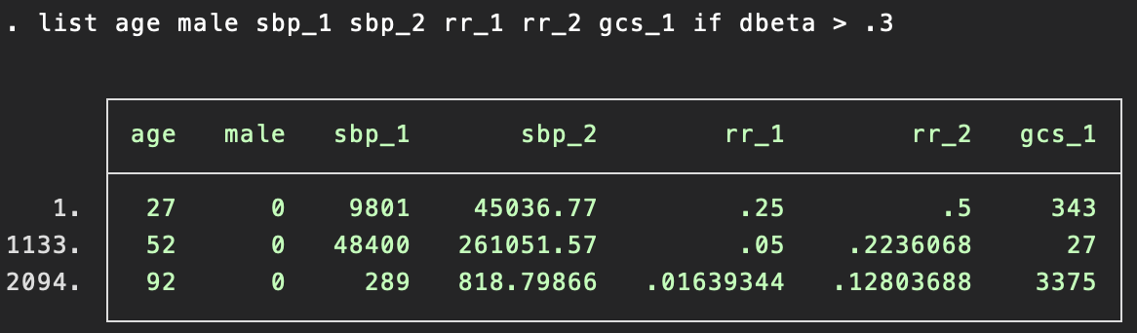

Model diagnostic shows problematic influential data points such as 1133, 2094, etc near pr(died) = 0.59 and pr(died)=0.78. Both values have a high delta chi square and high delta deviance compared to the other values. pr(died) has a comparatively high delta beta as well. However, we cannot simply exclude these from the analysis just to achieve better model fit. We need to consult with experts to see if deleting these outliers makes sense scientifically. We can refit the model interaction terms to achieve better fit and re-test goodness of fit and perform model diagnostics.

To refit the model, first change age to categorical for better fit, where age_cat = 1 if age <= 35, age_cat = 2 if 36 <= age <= 55 and age_cat = 3 if age > 55. Then change interaction term to simpler form with base terms instead of higher order terms as in the preliminary final model. The new final model is shown below, along with its corresponding goodness of fit test, which now indicate better fit than before (p=0.1217 compared to p=.0165).

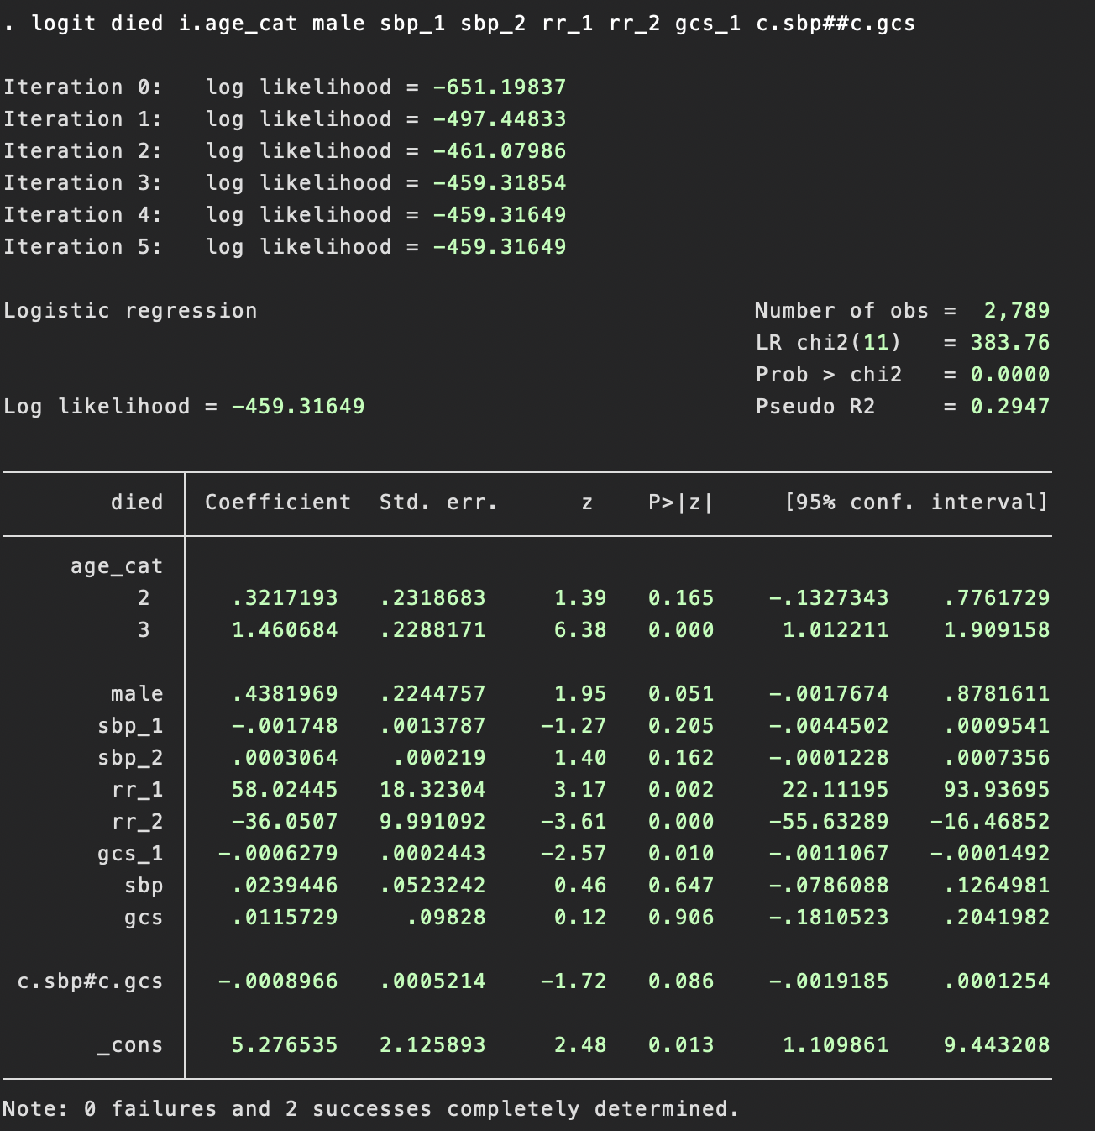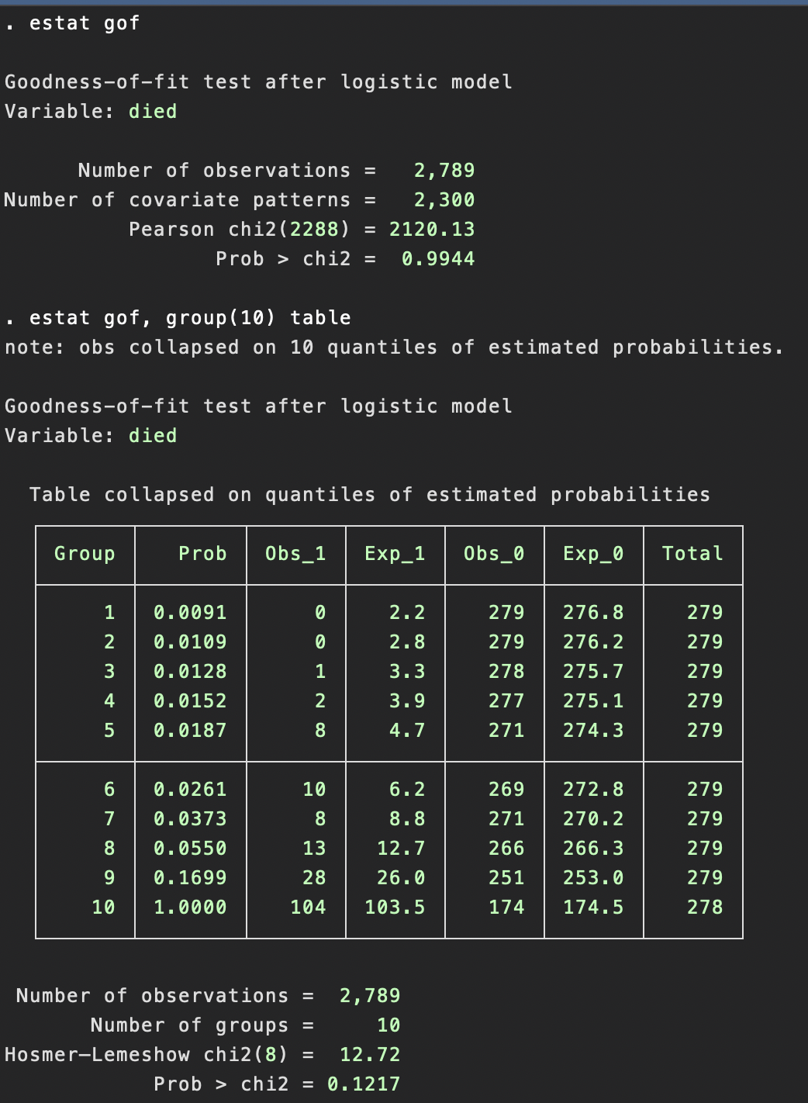

1. Provide a **publication-quality** table reporting your resulting model (variables, beta (SE), p-value).

Final model is produced below.

**Logistic regression**

|  |  |  |  |  |  |  |  |  |  |  |  |
| --- | --- | --- | --- | --- | --- | --- | --- | --- | --- | --- | --- |
| died | Coef. | | St.Err. | t-value | | p-value | [95% Conf | | Interval] | | Sig |
| RECODE of age (Age~1 | 0 | | . | . | | . | . | | . | |  |
| 2 | .322 | | .232 | 1.39 | | .165 | -.133 | | .776 | |  |
| 3 | 1.461 | | .229 | 6.38 | | 0 | 1.012 | | 1.909 | | *** |
| male | .438 | | .224 | 1.95 | | .051 | -.002 | | .878 | | * |
| sbp_1 | -.002 | | .001 | -1.27 | | .205 | -.004 | | .001 | |  |
| sbp_2 | 0.0003 | | 0 | 1.40 | | .162 | 0 | | .001 | |  |
| rr_1 | 58.024 | | 18.323 | 3.17 | | .002 | 22.112 | | 93.937 | | *** |
| rr_2 | -36.051 | | 9.991 | -3.61 | | 0 | -55.633 | | -16.469 | | *** |
| gcs_1 | -.001 | | 0 | -2.57 | | .01 | -.001 | | 0 | | ** |
| sbp | .024 | | .052 | 0.46 | | .647 | -.079 | | .126 | |  |
| gcs | .012 | | .098 | 0.12 | | .906 | -.181 | | .204 | |  |
| c.sbp#c.gcs | -.001 | | .001 | -1.72 | | .086 | -.002 | | 0 | | * |
| Constant | 5.277 | | 2.126 | 2.48 | | .013 | 1.11 | | 9.443 | | ** |
|  | | | | | | | | | | | |
| Mean dependent var | | 0.062 | | | SD dependent var | | | 0.242 | |
| Pseudo r-squared | | 0.295 | | | Number of obs | | | 2789 | |
| Chi-square | | 383.764 | | | Prob > chi2 | | | 0.000 | |
| Akaike crit. (AIC) | | 942.633 | | | Bayesian crit. (BIC) | | | 1013.834 | |
| *\*\*\* p<.01, ** p<.05, * p<.1* | | | | | | | | | | | |

1. Provide the model formula for predicting the probability of dying in the hospital.  
   linear predictor = 5.277 + .322(age_2) + 1.461(age_3) + .438(male) - .002(sbp)^2 + .0003(sbp^2)ln(sbp) + 58.024(1/rr) – 36.051 (1/sqrt(rr)) - .001(gcs)^3 + .024(sbp) + .012(gcs) - .001(sbp*gcs)

Pr(died) = exp(linear predictor)/(1+exp(linear predictor))

1. Provide an ROC curve, an estimate of the area under the ROC curve (AROC, with 95% CI) and a classification table for your model.  
   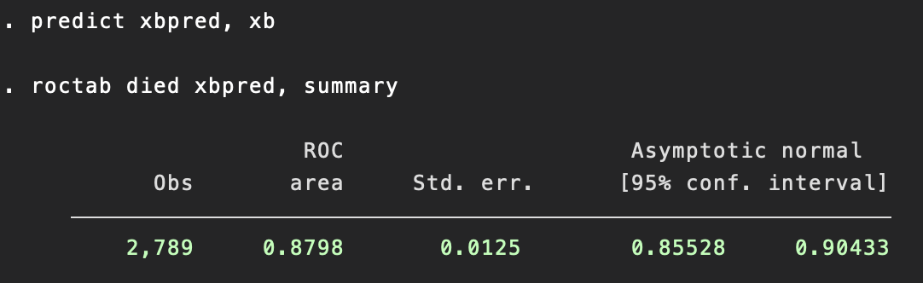  
   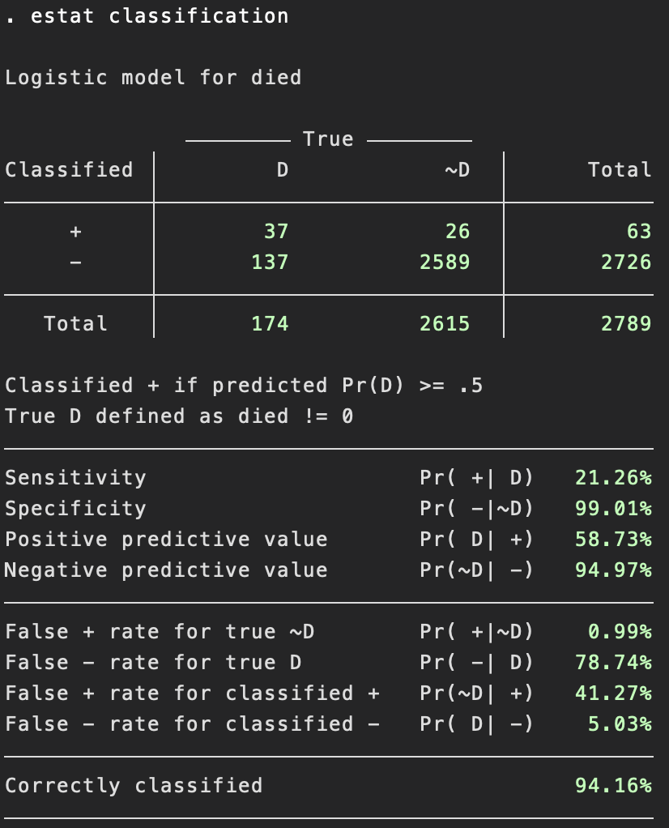

The ROC AUC of .8798(95% CI: .85528, .90433) is between 0.8- 0.9, indicating excellent classification.

1. Evaluate the usefulness of your predictive model **in the validation sample (val=1).** Write a short conclusion.Re-run the above final model in the validation sample only using (if val==1) and generate ROC, ROC AUC 95% CI, as well as classification table. Note that the if qualifiers restricting the dataset used in this question was not needed in previous questions because that was a manually edited sample containing only estimation observations (val==0). See more details in STATA smcl file.

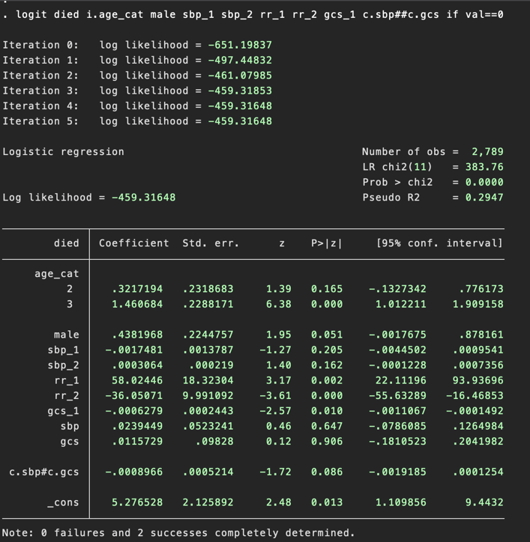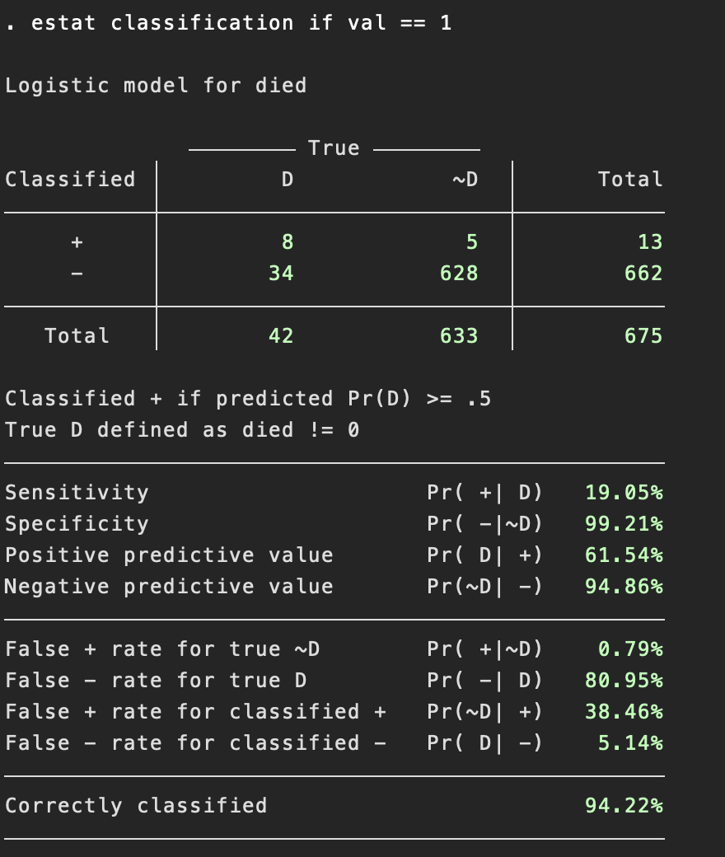

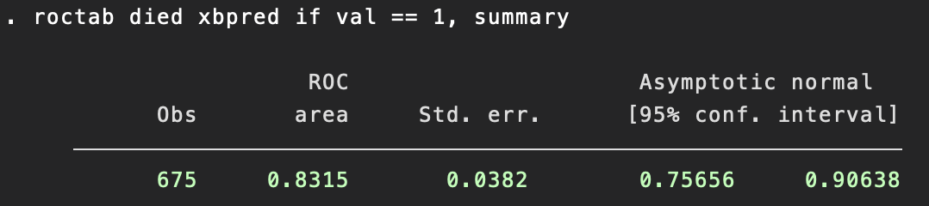

From this we can conclude that our model is useful in the validation sample because our ROC AUC is .8315(95%Ci: .757, .906) indicating excellent classification. The sensitivity and specificity are greatly improved if the cutoff point is set at 0.1 instead of 0.5. This optimizing cutoff point was chosen due to the sensitivity and specificity vs cutoff plot showing a cross of two curves at roughly cutoff=0.1, the new classification table is shown below.

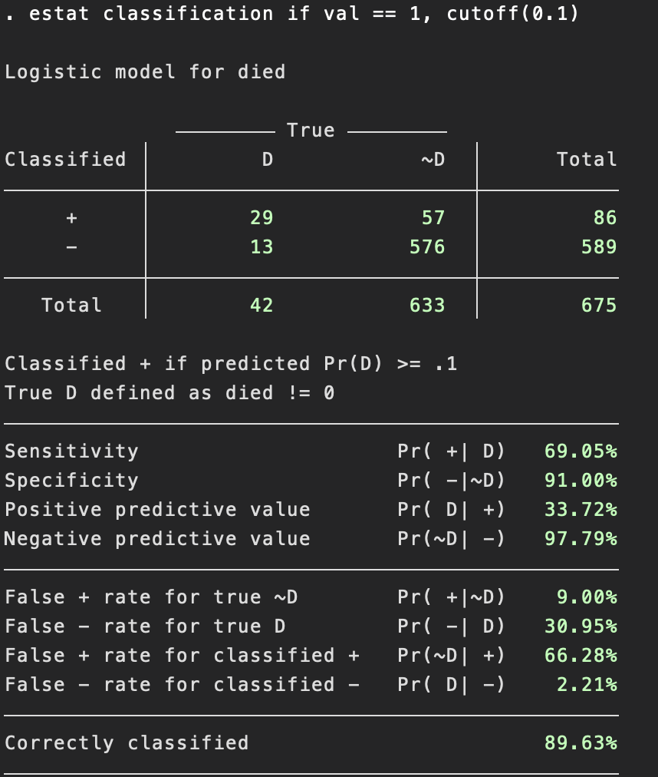

1. Write a paragraph on your statistical methods, including model development, for the investigator to use in the manuscript. **This should be publication quality text.**

To develop a predictive model for the probability of in-hospital mortality among patients admitted due to trauma, the dataset was split into estimation sample (n=2789) and validation sample (n=675). A summary statistics table was generated to show the basic demographic and clinical information of patients in the estimation sample.

Using the estimation sample, a predictive logit model was developed by first selecting variables into the preliminary model based on univariate regressions (p<.25). The preliminary model included age, race, sbp, rr and gcs. Then, race was removed from the model due to being non-significant. Gender was added back into the model because it is now significant in the model.

Next, fractional polynomial test to test linearity of individual continuous variables to determine possible transformations. Age was first tested, and the linear form of age was kept due other transformations not having a significant difference form linear form. Then, sbp was checked and it was transformed into two terms where sbp_1 = (sbp)^2, and sbp_2 = ((sbp)^2)*ln(sbp) based it having significant improvement over other transformations and having the least deviance. Then, rr was checked and it was transformed into a two-term model where rr_1 = 1/(rr) and rr_2 = (1/sqrt(rr)) with the same rationale as in sbp. And lastly, gcs was transformed to a 1-term model such that gcs_1 = gcs^3 due to the same reasons as in sbp.

At this point, the preliminary model has been transformed into logistic died age male sbp_1 sbp_2 rr_1 rr_2 gcs_1. The last step is to test for all 18 of the possible two-way interactions between base terms using lrtest. Two interactions turned out to be significant, namely sbp_1##gcs_1 (LR test p=.01) and sbp_2##gcs_1 (LR test p=.0097).

However, when both Pearson GOF test and Hosmer–Lemeshow GOF test were performed, the preferred Hosmer–Lemeshow showed that the model with such interaction terms had poor fit (p=0.0165). A subsequent refit of the model where age was transformed into age_cat (age_cat = 1 if age <= 35, age_cat = 2 if 36 <= age <= 55 and age_cat = 3 if age > 55) and interaction terms were restricted to base terms without transformations showed that the model fit improved (p=0.1217 in the new model).

Next, model diagnostic showed problematic influential data points such as 1133, 2094, etc near pr(died) = 0.59 and pr(died)=0.78. Both values have a high delta chi square and high delta deviance compared to the other values. pr(died) has a comparatively high delta beta as well. However, we cannot simply exclude these from the analysis just to achieve better model fit. We need to consult with experts to see if deleting these outliers makes sense scientifically. We can refit the model interaction terms to achieve better fit and re-test goodness of fit and perform model diagnostics.

Lastly, after testing for model usefulness using classification table, calculating specificity and sensitivity, plotting ROC curve, and calculating 95% CI for ROC AUC, the model was deemed useful in the estimation sample. The same model was then performed on the validation sample where the same test showed similar usefulness in terms of outcome classification.

1. Investigators hypothesized they could better predict in-hospital mortality in this population by adding a measure of fitness for surgery assessed in the ER prior to surgery. This measure is “asaps” in the dataset. Again **using just the val=0 sample:**
   1. Decide if the new asaps measure would be appropriate to add to your predictive model that you developed above. Do NOT modify your predictive model above (other than possibly adding the new asaps measure. Attend to proper modeling of the variable.  
      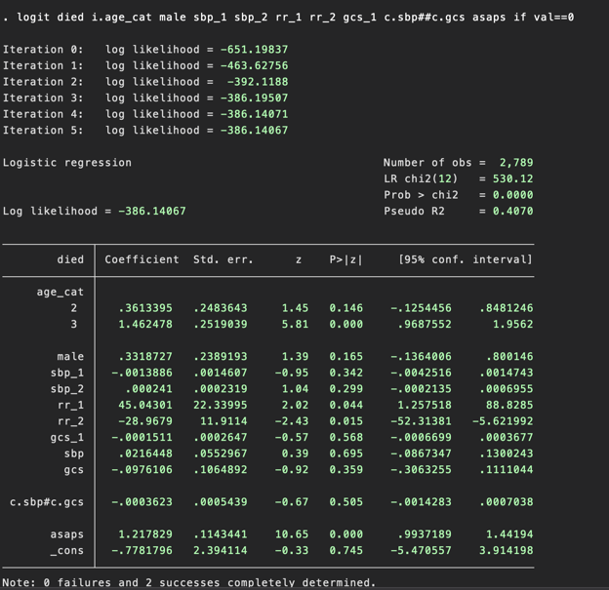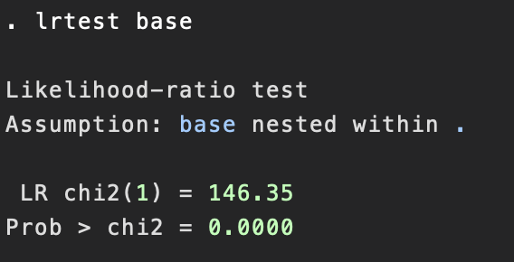

By adding the ASAPS variable into the existing final model, LR test shows that the model with the ASAPS variable is significantly different form the model without it (base model). So we conclude that ASAPS should be included in the model.

* 1. Assuming you have found that the new measure adds to your original prediction model, test whether addition of asaps adds significant prediction to the model in terms of the AROC (i.e., compare your full prediction model (with asaps) to your original prediction model).As we can see, the new AROC area is 0.923 (95% CI: .90207, .94386) where the 95% CI does not include the previous AROC without the ASAPS term (which was .8798). This means that the addition of ASAPS adds significant prediction to the model in terms of the AROC compared to the original model without ASAPS.  
     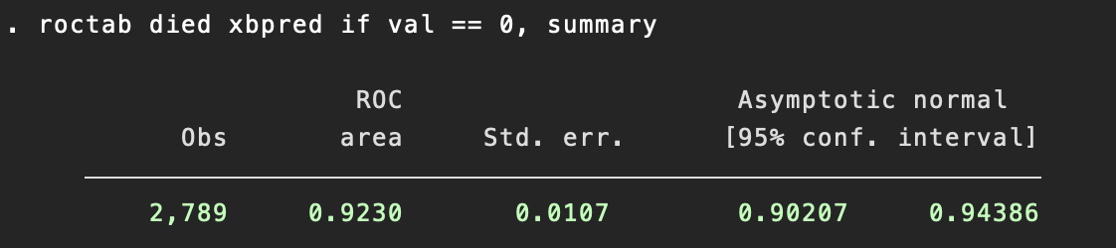
  2. Write a short conclusion, comparing your original prediction model to the enhanced prediction model.

The conclusion is that even though the enhanced prediction model provides significantly more prediction power than the original model 是 both in terms of AROC area according to their respective 95% CI and in terms of the likelihood ratio test of the two models. One thing to take notice is that having near perfect discrimination (>.90) may entail problems regarding quasi-complete separation which warrants further investigation and potential model re-fitting.